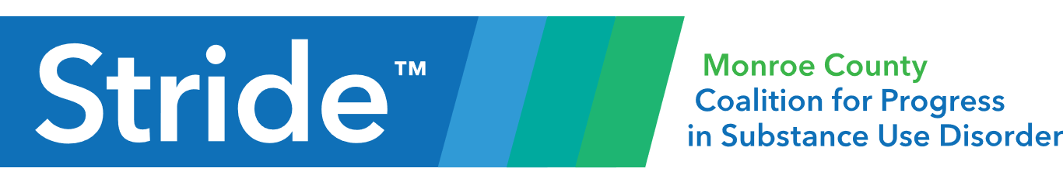

Fall and Winter Coat Drive

As it continuously gets colder, we cannot forget those in our community who do not have warm homes to go back to at the end of the day. Many people also are unable to afford warm clothing to keep them safe and comfortable.

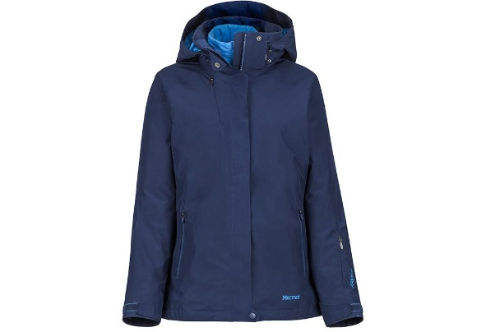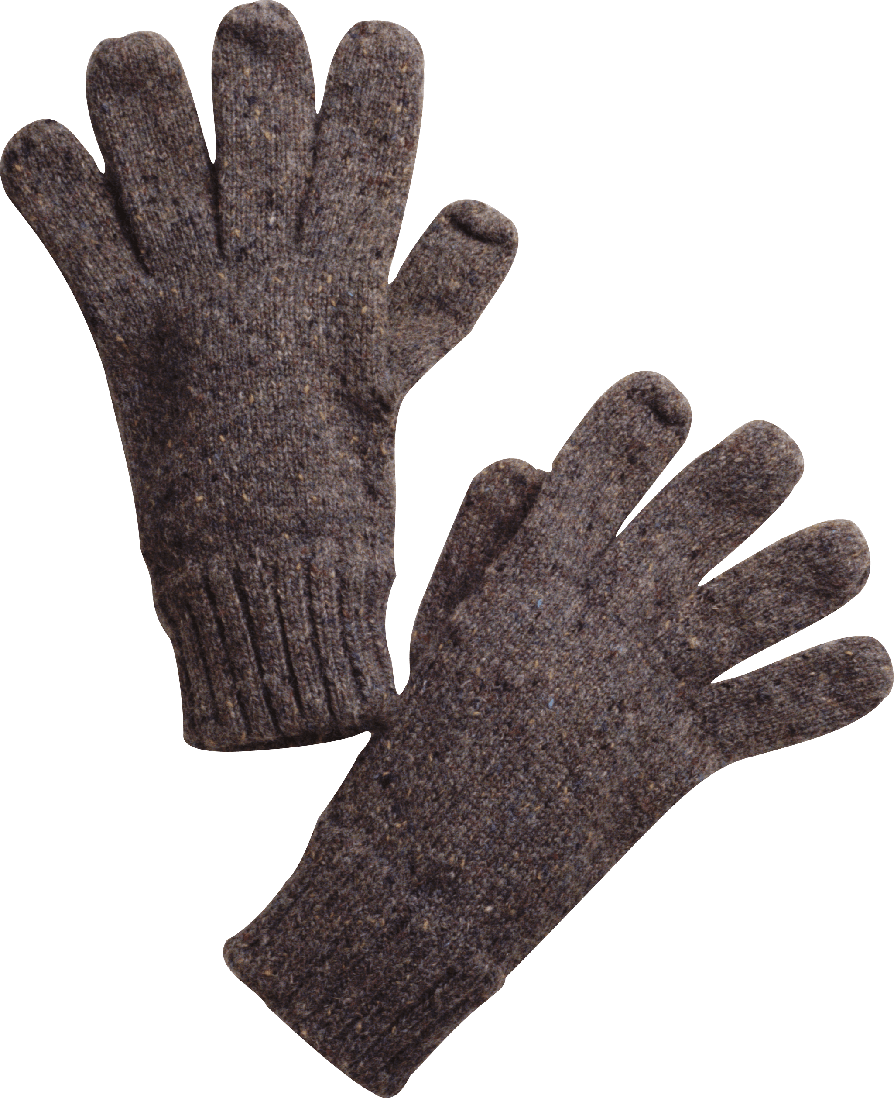 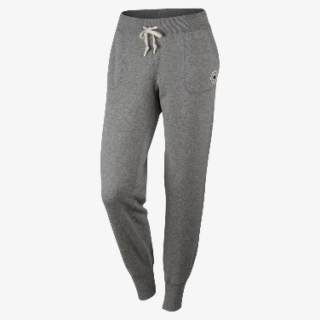

The Stride Center is now operating a coat drive. We are accepting any and all donations of adult warm clothing. We will be able to directly give these donations to individuals in need all winter.

Please wash your clothing before donating. If you do not have the ability to wash them, please let us know and we will wash them. You can bring them in to our facility or give them to a Stride employee to bring in.

The Stride Center is a 24 hour, low-barrier crisis diversion facility. For more information on what we do, please visit our website:

Stridecoalition.org

Or reach us by phone at:

812-650-4878

312 N. Morton Street, Bloomington, IN 47404