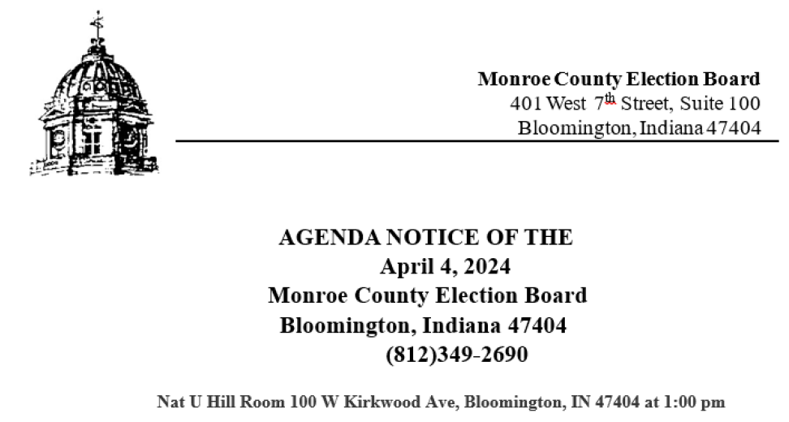

I. Call to Order

II. Approval of Minutes
III. Clerk’s Update
• Deadline for Registration
• Early Voting Start Date
• Candidate Sign Placement
• Election Day Workers Needed

- Public Comment

IV. Election Central Update
• Ballot Review Notes
• LAB Test Results
• Status of Election Readiness

- Public Comment

V. Vote Center Study Committee Update
• Meeting Updates – Ami Gandhi

- Public Comment

VI. Old Business
• Annual CFA-4 Hearings (Continued)

- Public Comment

VII. New Business
• Resolution to ratify approval of poll location
• Appointment of Absentee Board Members
• Recruiters – agreement with Party chairs
• Amendment to Monroe County Code Chapter 287
• Chapter 287 Resolution
• Council Resolution 2024-12
• Update on nominations of Election Day poll workers

- Public Comment

VIII. Motion To Recess or Adjourn

