Substance Use and Mental Health (SUMH) Community Health Improvement Plan (CHIP)
Connections Subcommittee
Date: 4.19.2023
Time: 1-2 pm
Location: Zoom
Facilitators: Melanie Vehslage and Ody Ekwonwa
Notes: Melanie Vehslage

Agenda item | Facilitator
- Welcome and Introductions  - Review CHIP Timeline and projects  - SUMH Timeline  - Would like to have an initial plan drafted by June 2023  - Timeline can be living document, but need a starting draft to move CHIP groups through first quarter 2025  - Helping Bloomington Monroe Provider List  - TASC (Meeting 2 materials on project timeline)  - Please fill out demographic info survey (please fill this out each meeting for Purdue Extension’s programing purposes)  - Program: TASC project for SUMH CHIP Sub-Committee  - Growing the Coalition handout  - Are there additional people/groups that should be invited to attend that are not here right now?  - If time, add names to invite during meeting  - Review ROSC mapping Model (see image below on page 2)  - Description of creating the map  - Interviews  - Interview Guide for Professionals  - Interview Guide for person in recovery or family member  - Jamboard to organize notes  - This is a pilot project, so if there are questions, let us know so we can relay to project developers for Monroe and other counties’ benefit  - Meeting moving forward  - To Do:  - Review Strategies Timeline – what needs to be added? What is irrelevant?  - Draft due June 2023.  - Indicate on the second page of Growing the Coalition handout at least one person to invite to May Connections Subcommittee meeting (and then invite them )  - Due by next meeting  - Conduct at least one interview by May Connections meeting  - Save your notes from the interview somewhere and use the Jamboard to organize notes from interview  - In person/zoom/hybrid?  - MCPL sometimes available, but would folks prefer MCHD or Purdue Extension for hybrid? | Melanie  Ody  Melanie
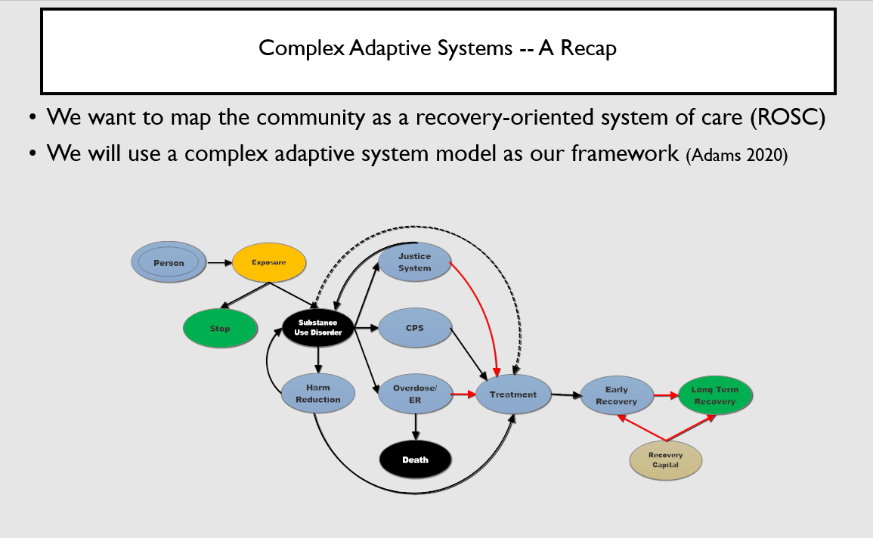
Melanie Vehslage is inviting you to a scheduled Zoom meeting.

Topic: Connections Sub-Committee of SUMH CHIP
Time: Apr 19, 2023 01:00 PM Eastern Time (US and Canada)
Every month on the Third Wed, until Dec 18, 2024, 21 occurrence(s)

Please download and import the following iCalendar (.ics) files to your calendar system.
Monthly: https://monroecounty-in.zoom.us/meeting/tZMtde6rrTkqEtEX2WRt2OnPYAVsiY7tUKYM/ics?icsToken=98tyKuGvrjktGdeXsBGCRpwEAojoKOnztnpfj7d4pE3SMTQBTQ3GD8N0IbtGR8zl

Join Zoom Meeting
https://monroecounty-in.zoom.us/j/87027332085

Meeting ID: 870 2733 2085
One tap mobile
+13126266799,,87027332085# US (Chicago)
+16465588656,,87027332085# US (New York)

Dial by your location
+1 312 626 6799 US (Chicago)
+1 646 558 8656 US (New York)
+1 646 931 3860 US
+1 301 715 8592 US (Washington DC)
+1 305 224 1968 US
+1 309 205 3325 US
+1 719 359 4580 US
+1 253 205 0468 US
+1 253 215 8782 US (Tacoma)
+1 346 248 7799 US (Houston)
+1 360 209 5623 US
+1 386 347 5053 US
+1 507 473 4847 US
+1 564 217 2000 US
+1 669 444 9171 US
+1 669 900 9128 US (San Jose)
+1 689 278 1000 US
Meeting ID: 870 2733 2085
Find your local number: https://monroecounty-in.zoom.us/u/kbcld5yGMJ

